

**University Institute of Technology RGPV Bhopal**

**Physics Project**

**Session: 2022 – 23**

**Title - Automated Waste Segregation Dustbin**

**Submitted By –**

* **Darpan Porwal 41**
* **Ishaan Mathur 60**
* **Mansi Malviya 78**
* **Aarushi Patel 03**
* **Bhawesh Choudhary 37**
* **Harshit Arya 56**
* **Divyakant Kushwaha 47**
* **Aishwarya Gupta 19**
* **Anuj Kushwaha**
* **Jayati Nilekar**

**Submitted To –**

**Dr. Richa Trivedi Mam**

**Abstract**

The Automated Waste Segregation Dustbin is a project aimed at automating the process of waste segregation to enhance waste management practices. By utilizing components such as a DHT humidity sensor, Arduino Uno, motors, ultrasonic sensor, motor driver, 12V battery, jumper wires, and a dustbin, this project effectively separates different types of waste based on their Humidity content.

The outcomes of this project is a user friendly easy to use and affordable solution to the waste segregation problems, which is common in many households. This project is made with domestic use in sight but with certain advancement in technology it can be feasible for Industrial use also.

The user of this dustbin just has to place the waste on top of the lid, then the humidity sensor will detect the Humidity content and then segregate in into respective section with the help of motors.

**THEORY**

This project was made with the idea of incorporating technology with the process of waste segregation for domestic use. Since the practice of separation of wet and dry waste is still not followed by many households, this project will completely solve the problem, since the user does not have to manually separate waste, instead the process will be completed automated and the waste will be automatically separated.

The project incorporates sensors and microcontrollers to automate the segregation of waste. The humidity sensor is employed to measure the Humidity content of waste items, with organic waste generally having higher Humidity levels compared to other types of waste. The ultrasonic sensor is utilized to detect the presence of waste objects in the dustbin. Acting as the central control unit, the Arduino Uno processes the sensor data and commands the motors accordingly. The motors are responsible for opening and closing specific compartments within the dustbin, facilitating waste segregation.

**Components Used**

* **Humidity Sensor:**

A device used to measure the Humidity content of waste items accurately. It helps identify organic waste based on its higher Humidity/moisture levels. Humidity sensors work by detecting changes that alter electrical currents or temperature in the air.

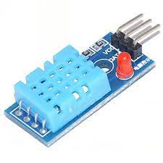

* **Arduino Uno:**

The **Arduino Uno** is an [open-source](https://en.wikipedia.org/wiki/Open-source) [microcontroller board](https://en.wikipedia.org/wiki/Single-board_microcontroller) based on the [Microchip](https://en.wikipedia.org/wiki/Microchip_Technology) [ATmega328P](https://en.wikipedia.org/wiki/ATmega328P) [microcontroller](https://en.wikipedia.org/wiki/Microcontroller) (MCU) and developed by [Arduino.cc](https://en.wikipedia.org/wiki/Arduino) and initially released in 2010. The board is equipped with sets of digital and analog [input/output](https://en.wikipedia.org/wiki/Input/output) (I/O) pins that may be interfaced to various [expansion boards](https://en.wikipedia.org/wiki/Expansion_board) (shields) and other circuits.

The board can be connected to power by a USB-B cable.

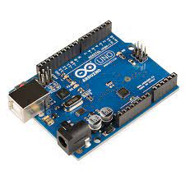

* **Motors:**

These motors play a crucial role in the project by physically opening and closing specific compartments within the dustbin. They are controlled by

the Arduino Uno and facilitate waste segregation. Out of the two motors used one is of 150 rpmrotations and the other is of 10 rpmrotations. The first used to open the lid of the dustbin without any physical contact of the user, and the second used to tilt the lid containing the Humidity sensor, so that the waste is dropped into its correct section of the dustbin.

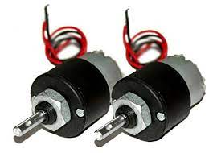

* **Motor Drivers:**

Motor driver is used to control motion of a motor and its direction by feeding current accordingly. Output of a motor driver is in digital form so it uses PWM (Pulse Width Modulation) to control speed of a motor. Motor Driver are basically current amplifiers followed by input signals. It can also drive inductive loads such as relays, solenoids, transformer etc.

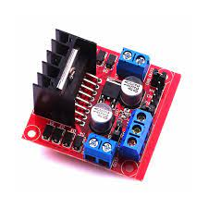

* **Ultrasonic Sensor:**

An essential component that detects the presence of waste objects within the dustbin. It helps trigger the Humidity sensor and initiates the waste segregation process. It uses the concept of refletion. It is

an instrument that measures the distance to an object using ultrasonic sound waves. Ultrasonic waves travel faster than the speed of audible sound (i.e. the sound that humans can hear). Ultrasonic sensors have two main components: the transmitter (which emits the sound using piezoelectric crystals) and the receiver (which encounters the sound after it has travelled to and from the target).It then calculates the distance using the time taken for the wave to return to the sensor.

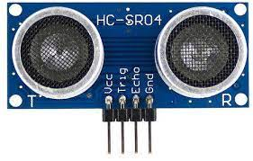

* **12V Battery:**

A portable power source that provides the necessary electrical energy to run the entire system. It ensures that the project can operate autonomously without relying on an external power supply.

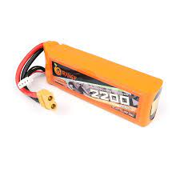

* **Jumper Wires:**

These wires are used to establish electrical connections between the different components of the system. They enable seamless communication and data transfer among the sensors, microcontrollers, and motors.

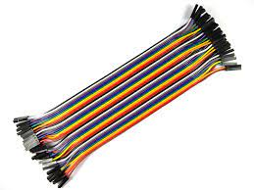

* **Dustbin:**

The primary container where waste items are deposited for segregation. The dustbin is designed with separate compartments that can be opened and closed by the motors, allowing for efficient waste sorting.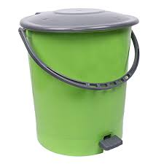

**WORKING**

The automated waste segregation dustbin is a complex machine that uses different types of sensors and motors to detect the type of waste that has been put in it and separate it. It requires no manual intervention and is very simple to use, hence being extremely user friendly.

The structure of the dustbin is formed by dividing the original dustbin into 2 sections using cardboard, and then installing a see-saw type cover (attached to a motor) to flip the waste into whichever section that is needed. The original plastic lid is also attached to a motor to automate the process of opening of the dustbin

The Humidity sensor is connected to see-saw lid. This will also serve as the platform to keep the waste that has to be sorted. The ultrasonic sensor is connected to the cover lid which will help open the cover lid without any manual intervention.

The system initiates by initializing the sensors and establishing communication with the Arduino Uno. The ultrasonic sensor continuously monitors the distance between the waste object and the sensor, when the object is within the desired distance the lid will automatically open and the waste fill fall. When an object is detected within the dustbin, the Humidity sensor measures its Humidity content. The Arduino Uno receives data from both sensors and makes decisions based on predefined Humidity thresholds. If the Humidity content surpasses a specified value, indicating organic waste, the Arduino commands the corresponding motor to open the organic waste compartment. Conversely, if the Humidity content falls below the threshold, indicating non-organic waste,

another motor opens the non-organic waste compartment. The waste is segregated accordingly, streamlining recycling or disposal processes.

This whole setup will be battery powered, so that it can be easily transported or carried around making it user friendly.

.

**PIN DIAGRAM AND CONNECTIONS**

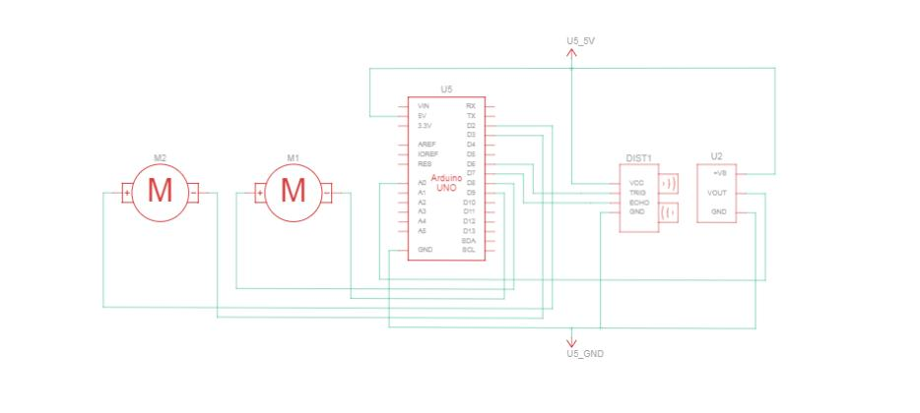

**Thought Process Behind The Making Of This Project**

The automated bin for wet and dry sorting of waste is an innovative solution that has several advantages for society and solves many problems. By incorporating advanced technology, such a bin can effectively separate wet and dry waste, leading to significant benefits in waste management and environmental sustainability. Here are some key benefits of an automatic damp and dry waste sorting bin and how it can help the environment:

* **Waste segregation not being a habit:**

Most households in India don’t even have a second dustbin for wet and dry waste, hence leading to health and sanitary issues. With our automated waste segregation Dustbin this problem is solved as there is no need for multiple dustbins, and to manually sort out wet and dry waste, this dustbin automatically detects the type of waste and separates them is different sections hence solving these problems

* **Improved waste management:**

One of the main problems of a normal dustbin is its ability to disability to sort waste. By making the process automated, separating wet and dry waste is simplified. This ensures that waste is disposed of in an organised and systematic manner, making it easier for waste management authorities to handle and process different types of waste.

* **Recycling problems:**

Proper separation of wet and dry waste is essential for efficient recycling. A normal dustbin (non- automated) cannot ensure that wet waste such as food scraps and organic matter is separated from dry waste such as plastic, paper and metal. Hence an automated separation of waste enables efficient recycling of dry waste materials, reduces the burden on natural resources and promotes a circular economy.

* **Burden on landfills:**

Without proper segregation of waste all of the waste is dumped together in a landfill and it becomes extremely difficult sorting the waste. The automated bin significantly reduces the amount of waste that ends up in landfills as it separates the waste at its source only. Landfills also contribute to environmental pollution and health risks. Proper sorting of waste reduces the volume of waste going to landfills, which minimizes the load on these devices and extends their service life.

* **Environmental protection:**

Waste management is closely linked to environmental protection. The automatic dustbin supports responsible waste disposal practices and minimizes the negative impact of waste on the environment which a normal dustbin is not able to do so. By separating organic waste that can be composted from dry waste that can be recycled or upcycled, the bin supports a greener approach to waste management and helps reduce greenhouse gas emissions.

* **Health and Hygiene Problems:**

Improper segregation of waste can lead to decrease the overall level of hygiene and sanitation in society. Separating wet waste, which is susceptible to decomposition and odour, from dry waste significantly reduces the possibility of odour and bacterial growth. This leads to a cleaner environment, healthier living conditions and a reduced risk of disease transmission. Hence an automated waste segregation Dustbin also solves this problem.

* **Educational Value:**

The automatic wet and dry waste sorting bin can also serve as an educational tool to raise awareness of waste management practices. By visibly demonstrating the importance of segregation, it educates individuals and communities about responsible waste disposal. This knowledge can then be applied in other areas of life, leading to a greener and more sustainable society.

**Scopes For Improvement:**

In order to completely interpret this project its limitations are also to be considered side by side to its benefits, so that those can be removed in the future versions. In the limited time period this project for prototyped there are still many fields where there is scope of improvisation and improvement, which are listed below:

* **The quantity of waste that can be dumped at one go**:

Since the lid containing the Humidity sensor has to process and detect the type of waste that has been placed, it would have difficult if wet and dry waste is dumped simultaneously or if large quantity of waste is dumped at once, it would limit the working of the project.

* **Exposed electronics components:** Since most of the sensors and other components will be exposed, there is a chance that their life will be reduced due to the different factors that will be affecting them such as water leaks, rotting wastes etc. In future if its further developed we can make use of a printed circuit board to minimize the wired clutter and to make if more systematic, safe and easy to use.
* **Not feasible for industrial or heavy uses:** Since this prototype is made in a limited time period, there are various factors that limit the use of this dustbin on a large scale. One of them being that the waste has to be dumped one by one to accurately separate them, which increases the time for waste disposal. Other being the size factor limited number of sensors that can restrict the usage of this project beyond a certain threshold.
* **Low Accuracy**: Since the Humidity sensor is primarily to detect the Humidity content, it can give misreads regarding the type of waste that

has been dumped in it. One example being that if plastic or aluminum which comes under dry waste can be confused for wet waste if its wet. Vice versa is also true, example being onion peels which have very low quantity of Humidity and can be misunderstood for dry waste.

**CONCLUSION**

**The Automated Waste Segregation Dustbin project presents a practical and innovative solution for enhancing waste management practices. By employing various components such as Humidity and ultrasonic sensors, motors, and an Arduino Uno, the project successfully automates waste segregation based on Humidity content. This automation significantly reduces the manual effort required for waste sorting and improves the efficiency of recycling and disposal processes. The project contributes to sustainable waste management practices, promotes a cleaner environment, and opens avenues for further optimizations and customization to meet specific waste segregation requirements.**